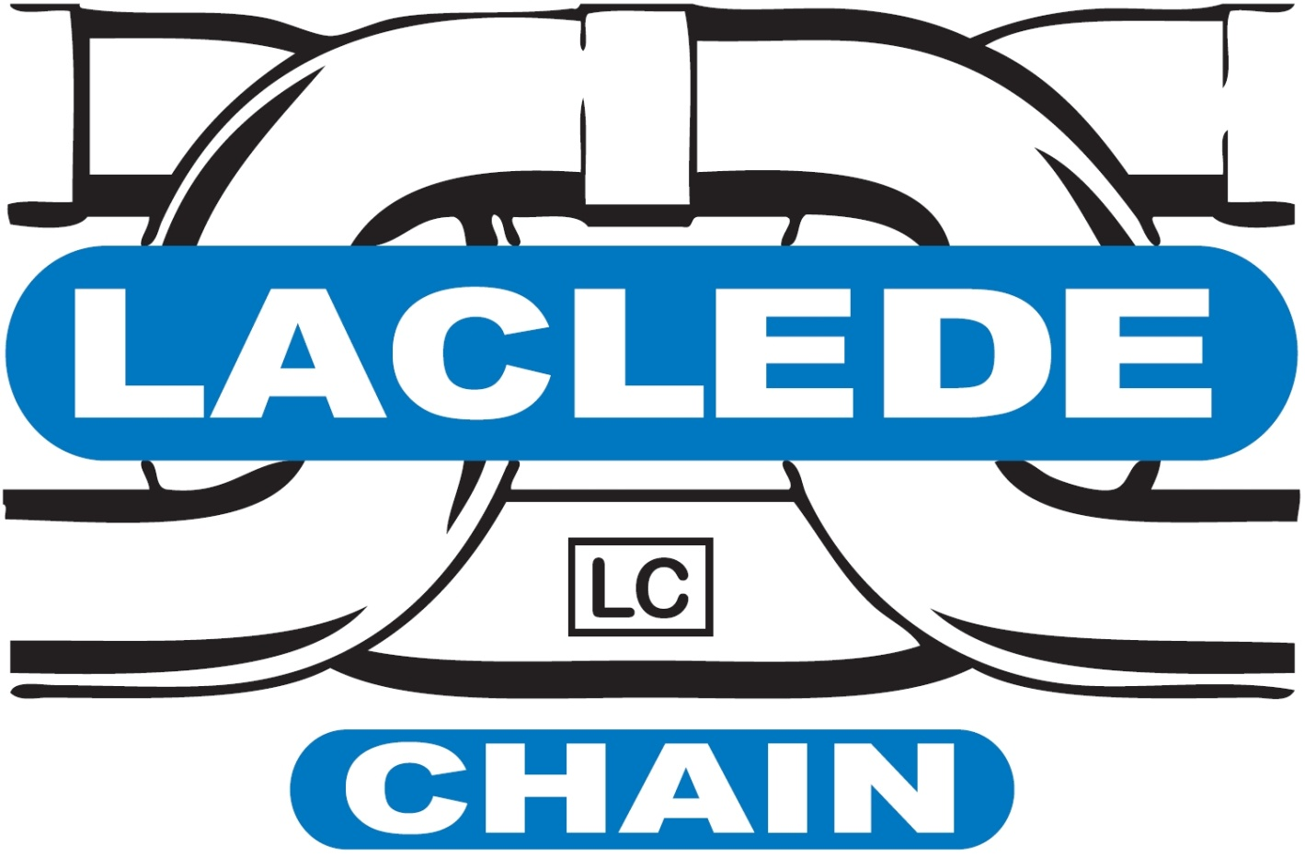
Position Title: MRO Buyer/Purchasing Agent
Location: Maryville, MO
Department: Supply Chain
Reports to: Director of Materials
Laclede Chain Manufacturing has origins dating back to 1854 when we manufactured hardware for the wagon trains heading out west. Our rich history started with having innovative and hardworking people. People continue to be the backbone that makes Laclede Chain a great place to work. We are a family owned American company that continues to be a force in the chain industry. Our teams promote a safe and fun working environment. We were recently recognized with a gold award by the Association of Wire Rope Fabricators for having an outstanding safety record during the 2015 year.
We are needing more innovative and hardworking individuals to help our company continue to grow. As the only family owned business in our industry, we have the capability of being flexible. Our flexibility allows us to quickly promote from within, offer competitive wages and a generous benefits package. The package includes health care, vacation, paid holidays, and a 401K.
Position Summary: Coordinates activities involved with procuring goods and services such as equipment, tools, parts, and supplies for the Company as well as providing administrative support to the department.

Key Duties and Responsibilities:
- Reviews requisitions
- Confers with vendors to obtain product or service information such as price, availability, and delivery schedule
- Selects products for purchase by testing, observing, obtaining samples or examining items
- Estimates values according to knowledge of market price
- Determines method of procurement such as direct purchase or bid
- Prepares purchase orders or bid requests
- Reviews bid proposals and negotiates contracts within budgetary limitations and scope of authority
- Maintains procurement records such as items or services purchased, costs, delivery, product quality or performance, and inventories
- Discusses defective or unacceptable goods or services with users, vendors, and others to determine source or trouble and take corrective action
- Approves invoices for payment
- Expedites delivery of goods to users
Core Competencies:
- Problem Solving skills
- Technical skills
- Customer Service
- Interpersonal Skills
- Communication Skills—Oral and Written
- Ability to work as a team or individually
- Good work ethic—efficient, effective, accurate, organized, conscientious, dependability, punctual, etc…
- Meets Company standards (i.e. goals and objectives, production quotas, project deadlines, etc…) and with high quality
- Adaptability—changes in the work environment, production demands, priorities, methods, direction, etc…
- Takes initiative
- Innovative/Resourceful
- Analytical
- Diversity—shows respect and sensitivity to cultural differences
Education:
- High School Diploma or GED or equivalent work experience

Required Qualifications:
- Minimum of 3-5 years’ experience purchasing in a manufacturing environment.
- Ability to read and interpret documents such as safety rules, operating and maintenance instructions, and procedure manuals.
- Ability to write routine reports and correspondence.
- Ability to speak/present effectively to individuals and/or groups (both internal and external).
- Apply basic mathematical skills—add, subtract, multiply, divide in all units of measure (including using whole numbers, common fractions, and decimals).
- Intermediate to advanced computer skills with Word, Excel, PowerPoint, especially to put together charts, compare and analyze data, and present proposals or negotiations.
- Detail oriented with ability to handle multiple projects and priorities at one time.

Physical Demands/Work Environment:
- Must be able to stand, walk, bend, stoop, kneel, crouch, reach overhead, or crawl
- Must be able to lift 25lbs, at times may be asked to lift more
- Environment is primarily within an office
- Production floor is typically loud, non-climate controlled
- Must wear required PPE when on the production floor or visiting other facilities that require such
_________I have received, reviewed and fully understand this job description. I further understand that I am responsible for the satisfactory execution of the essential functions described therein, under any and all conditions as described. I acknowledge that I am able to perform the job responsibilities and meeting the job requirements with or without accommodation. I certify that the information provided by me in regards to this form is true, complete, and I understand that any false statements made as part of this form may result in denial of employment or dismissal.
_______________________________________________ ______________________
Employee Printed Name Date

